**RECAP**

**What is an MFD?**

It is a device that allows printing, copying, and scanning as well as providing additional functionality, such as scanning to email. Multifunctional devices are faster than conventional printers and have faster print speeds.

**What do we mean by secondary storage?**

To keep data and programs indefinite, secondary storage is necessary. If secondary storage were not used, all data and programs would be lost when the computer is turned off.

**Give an example of an input device?**

* Keyboard
* Mouse
* Scanner
* Camera
* Microphone

**Give an example of an output device?**

* Monitor
* Speakers
* Printer
* Headphones
* projectors

**What is one benefit of optical storage?**

Compared to other types of storage, optical is most durable.

----------------------------------------------------------------------------------------------

**Task 1**

**What is the purpose of the CPU?**

* The CPU is often known as the brain of the computer
* Its job is to process data. (Search, sort, make choices and calculate)
* When using a computer, it is the CPU which is at the heart of everything.

The main components of the processor include the following:

* Control unit (CU)
* Arithmetic Logic Unit (ALU)
* Register
* Buses

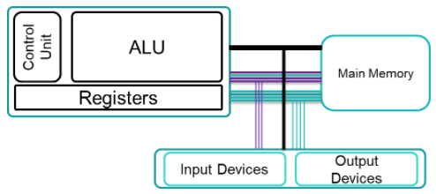

**The Accumulator (ACC)**

The accumulation of the CPU is a register which temporarily holds data values in logic and mathematic equations.

**The Program Counter (PC)**

Program counter holds the address of the instruction which is currently being executed. The program counter increases by 1 each time an instruction is fetched.

**The Memory Address Register (MAR)**

The memory address register holds the place of data which needs to be accessed.

**The data bus**

This bus is responsible for moving data between the CPU and the main memory.

**The Address bus**

This bus is responsible for communicating the memory locations of the data instruction that needs to be fetched between devices.

**The control bus**

This bus is responsible for communicating control signals from the control unit.

**Task 2**

**Clock speed**

The clock speed represents how much cycles per second can be executed. Can also be referred to as clock rate. Clock speed/Clock rate is measured in gigahertz (Ghz)

**Number of cores**

Within the CPU we have one or more processing units, and each is called a core. Core contains registers, ALU and control unit. Commonly computers have 2 cores or 4 cores. More cores mean more instructions can be done.

**Size of cashe**

Cashe is used to store instruction and data that the processor will reuse. The larger a cashe the more data is holds.

**Cashe**

CPU can work very quickly indeed but unfortunately CPU’s can only work when supplied with data. The RAM cannot work at the same speed.

To overcome this the CPU’s cashe memory will not just copy the instruction needed at that time, instead it will also copy the continuing instruction.

Cashe memory has read speed like the CPU and is therefore much faster.

**Task 3**

RISC stands for 'Reduced Instruction Set Computer Whereas CISC stands for Complex Instruction Set Computer.

